Computer Modelling: Exercise 2 Report
s1610961
Introduction
In this project we simulated the interaction between two molecules in a Morse potential using two different time integration methods; symplectic euler and velocity verlet. We plot the separation of the two molecules as a function of time and also the total energy of the system as a function of time. We now compare the two methods of time integration.

Comparing time integrators
We compared how the total energy fluctuations of the system varied as we increase. To do this we wrote code that looped over each time integration method for different values of and calculated the corresponding energy fluctuation for each . We then plotted the energy fluctuations as a function of timestep .
Our energy fluctuation was calculated as follows:

For both time integrators we looped over 500 values of in the range , and used nitrogen molecules without spin as our molecules.
The results obtained are plotted in Fig.1 and Fig.2.

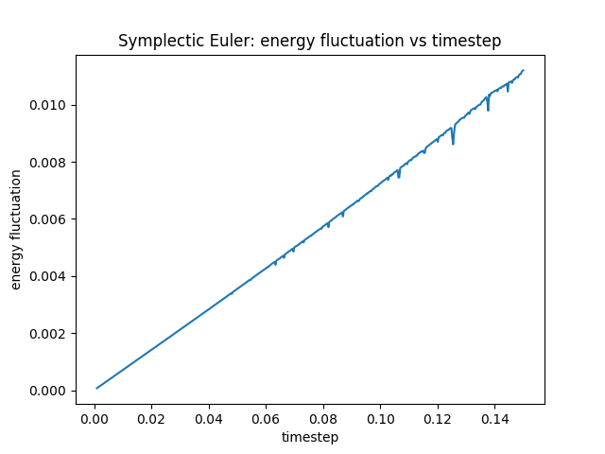
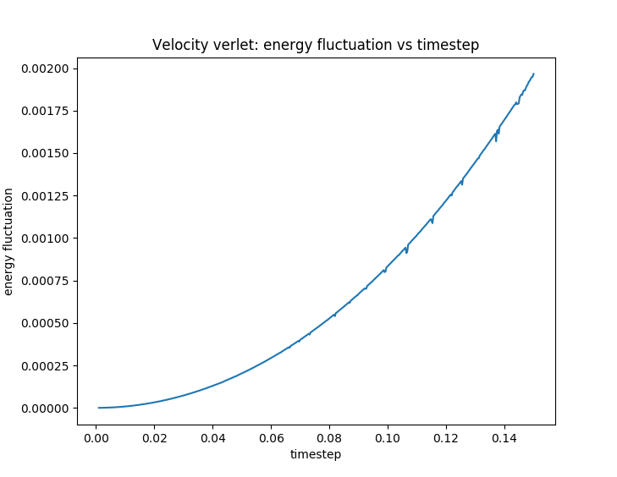

We can clearly see from the graphs that the energy fluctuation using symplectic euler increases much faster with increasing than it does on using velocity verlet. In other words, velocity verlet allows us to use a much larger timestep for the same relative energy error. To calculate (the maximum that can be used to simulate the system with a relative energy fluctuation of less than ), we wrote code that ran through our list of energy fluctuations and picked out the first energy less than along with the corresponding timestep. The results are summarised in Table 1, and show that velocity verlet is superior by order of magnitude.

Table 1

Vibrational Frequencies
Using the velocity Verlet integrator, and with set to , we will determine the vibrational frequencies for both and by analysing the period of oscillation of the particle separation. The graphs of particle separation against time are shown in Fig.3 and Fig.4.
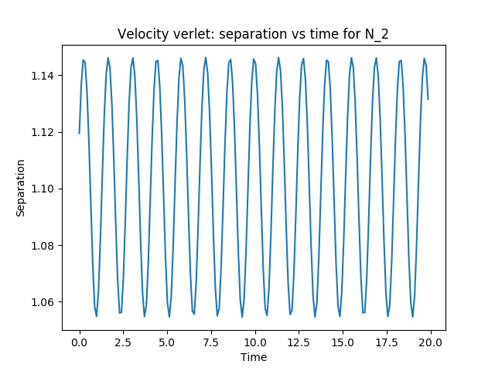
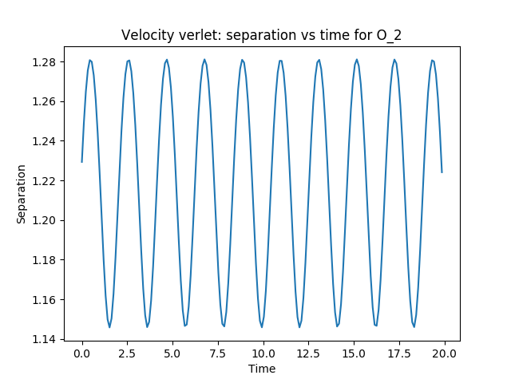

We calculated the period of oscillation by subtracting the separation value of the first peak from that of the last peak (which we read from the output file) and dividing by the total number of oscillations (for example the total number of oscillations in Fig.3 is 14). This gave values of 1.440 and 2.022 for nitrogen and oxygen, respectively. To convert these numbers to frequencies in units of inverse centimetres, we wrote a short programme called “unit_converter.” This returned values of 2275and 1620for the vibrational frequencies of nitrogen and oxygen, respectively. The nitrogen frequency that we calculated is 3.56% less than the experimental value of 2359. The oxygen value that we calculated is 2.53% greater than the experimental value of 1580. Thus, given these values are only a couple of percent out from the experimental data, we can conclude that our model of the system is reasonably accurate.

